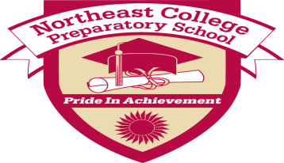
Northeast College Preparatory School Lesson Plan
Teacher(s): Mr. Holloway Grade: Middle School, 7/8
Subject(s):Technology Date of delivery: 11/13-11/16 Classes
meet every other day!

- Common Core Learning Standards Addressed:

Writing Standards: Standard 6- Use Technology, including the internet, to produce and publish writing and to interact and collaborate with others.
NYS Standards: Standard 5 - Technology

- Learning Target(s): (What will the students know and be able to do as a result of this lesson?)

Students will be able to make a pamphlet, using Microsoft Word!

- Essential Question(s)/Guiding Question(s):

How do you set-up a Microsoft Word document, to design a greeting card or a pamphlet?

- Higher Level Thinking Questions to be used during the lesson:

How do you create a trifold using Microsoft Word?

- Bridge/Connections/Hook:

Students will be able learn how to layout Microsoft word documents, so they can develop resources for any
project or paper they will do in any other class.

- Materials/Resources/Technology Integration:

Computer w/ Internet!

- Mini Lesson/Process/Procedure:

Go over with the students on how to layout a two column document.
-Adjust settings!

- Work Time/Activities/Tasks: (What learning experiences will students engage in? How will you use these learning experiences or their student products as formative assessment opportunities?)

Students will be creating greeting cards to show what they have learned.

- Access for All: (How will you ensure that all students have access to and are able to engage appropriately in this lesson? Consider all aspects of student diversity.)

As the teacher goes over the lesson, the students will be setting up their documents. Step by step
process for the first activity.

- Homework/Extensions/Enrichment:

N/A

- Formative Assessment Criteria for Success: (How will you and your students know if they have successfully met the outcomes? What specific criteria will be met in a successful product/process? What does success on this lesson’s outcomes look like?)

Individually, students will create greeting cards!

- What adjustments will be made for students that do not meet the Criteria for Success?

Students will receive individual help, while they are creating their greeting cards. If students need
additional time, they will have it.

Reflections:
- How does this lesson reflect academic rigor?

The teacher will only show a couple of steps on setting up their documents. From there, the students
will have to complete the activity.

